Chapter 1: Basic Introduction and Installation Tutorial for CARLA

introduction
The following content is CARLAThese are study notes, primarily focusing on the translation of official reference manuals, supplemented with background information. They are intended solely for learning, discussion, and future reference. Additionally...Here is the official website address for CARLA.forReader InquiryPlease provide this information for reference only. Any omissions or deficiencies are welcome to be pointed out and corrected..
1.CARLA official website address http://carla.org/
2.CARLA official website documentation address https://carla.readthedocs.io/en/latest/
3.CARLA Chinese Official Website https://carla.org.cn/#/
4.Github: https://github.com/carla-simulator/carla
CARLA is an open-source simulator developed by the Computer Vision Center at the Autonomous University of Barcelona, ​​Spain. Its goal is to provide comprehensive support for the development, testing, and validation of autonomous driving systems. Built on Unreal Engine, CARLA allows users to experience highly realistic urban traffic scenarios and a variety of vehicle models.
This simulator supports multiple programming languages, including Python and C++, and provides a rich set of APIs and communication protocols, enabling users to easily integrate with other systems. CARLA also offers flexible sensor configuration options, allowing users to acquire simulation data using sensors such as cameras and LiDAR as needed. In addition to providing a rich simulation environment, CARLA comes with numerous tutorials and example scripts to help users quickly get started and master its functions. Through these tutorials and examples, users can learn how to test and validate vehicle control, path planning, and decision-making algorithms.
In summary, CARLA is for the development of autonomous driving.,testand related researchProvided a powerfulandFlexiblesimulationThe platform provides an ideal tool for researchers and developers..

Basic Introduction to CARLA

Basic architecture
CARLA consists of two modules(ServerClient)The system is composed of two modules: the Server module, which is mainly used to build the simulation world (including traffic environment, traffic participants, traffic infrastructure, etc.), and the Client module, which is controlled by the user to adjust the various modules of the simulation world to achieve their own purpose.
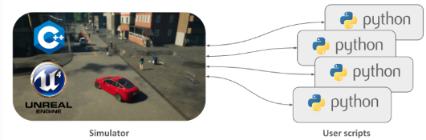
picture1CARLA has two modules (left - Server, right - Client).
①The Server module in CARLA handles everything related to the simulation itself: sensor rendering, physics calculations, updating the world state and its participants, and so on. Since its goal is to achieve realistic results, the most suitable approach is to run the server using a dedicated GPU, especially when dealing with machine learning. In other words, the Server acts as the brain of this virtual world, handling all simulation-related tasks such as sensor rendering (simulating what the sensors see), physics calculations (simulating vehicle collisions, acceleration, etc.), updating the world state, and monitoring the behavior of other participants in the simulation. Imagine you are testing a new autonomous driving system. You can use CARLA to create a virtual city scene with various vehicles, pedestrians, traffic lights, etc. Then, you let the configured autonomous driving system drive in this virtual world. CARLA's Server will simulate the entire process, including how the imported autonomous driving system perceives its surroundings, makes decisions, and ultimately achieves its driving effect.
②The Client module in CARLA consists of a series of client modules that control the logic of characters in a scene and set world conditions. It is implemented using the CARLA API (using Python or C++), which is a layer between the server and client, constantly evolving to provide new functionality. For example, imagine you want to test the performance of an autonomous car driving in the rain. You can use the server to create a virtual scene, set rainy conditions, and then place the autonomous car in this virtual environment. Through the client, you can control the car's direction and speed, and observe its performance in rainy conditions to evaluate the performance of the autonomous driving system.

Core Module
The basic architecture of CARLA forms the basic operating logic of CARLA, and its core modules mainly consist of six aspects.
①The Traffic Manager: Think of it as the traffic controller in CARLA, controlling all vehicles except the one being learned. It recreates a realistic city environment by coordinating vehicle behavior. For example, in a simulated city environment, the Traffic Manager controls vehicle behavior such as direction, speed, and stopping to simulate real traffic conditions.
②Sensors: In CARLA, sensors connect to the vehicle and collect data for various purposes. CARLA supports various types of sensors, such as cameras, radar, and lidar, acting like the vehicle's eyes and ears, providing information about the surrounding environment.
③Recorder: A recorder allows users to record data during a simulation and replay it for analysis when needed. For example, if an accident occurs during a simulation, the user can use the recorder to replay the simulation and see what caused the accident.
④ROS bridge and Autoware implementation: ROS and Autoware are open-source software platforms commonly used in autonomous driving systems. The CARLA simulator, through its integration with these platforms, allows developers to integrate the CARLA simulation environment with existing autonomous driving systems for more realistic and comprehensive testing and validation.
⑤Open assets: The CARLA simulator offers a wealth of open assets, such as various types of city maps, weather conditions, and prefabricated objects. Users can customize these assets to their needs, such as changing the layout of city maps or adding new buildings and road signs.
⑥Scenario runner: The scenario runner provides users with various driving scenarios to simulate different driving situations and challenges. For example, users can choose to simulate scenarios such as changing lanes on a highway or parking on a city street to help their vehicles learn and improve driving skills.

Functions and their ecosystems
CARLA is a comprehensive simulation platform used for research and development related to autonomous driving. Its main components include Actors, Maps, Sensors and data, Traffic, Third-party integrations, Development, and Custom assets.
1. Roles: Defined as the characters (participants) in the CARLA simulation world, mainly including vehicles and pedestrians, as well as sensors, traffic signs, traffic lights, and spectators. Roles (participants) are elements that perform actions in the simulation, and they can affect other roles (participants).
2. Map: Location and navigation in the simulated world. The map includes 3D models of towns and their road definitions. The road definitions are based on OpenDRIVE files, a standardized format for annotated road definitions.
3. Sensors and their data: Sensors are participants that retrieve data from the surrounding environment, contributing to the creation of the driving environment. Different types of sensors produce significantly different data; detailed information on these differences and functions can be found on the CARLA website. The data is the tangible representation of sensor information stored on a hard drive, usable in various environments.
4. Traffic: Traffic simulation is an indispensable part of accurate and efficient training and testing of the autonomous driving stack. CARLA offers many different options for simulating traffic and specific traffic scenarios, including Traffic Manager, Scenario Runner and OpenScenario, Scenic, and SUMO.
5. Third-party integration module: CARLA was developed to integrate with multiple third-party applications to maximize its usability and scalability.
6. Development: CARLA is open source and highly scalable. This allows users to create custom features or content to meet specific applications or needs, including content upgrades, tag creation, creating new sensors, and more.
7. Customizable Resource Modules: CARLA boasts a rich array of assets, including complete towns and cities, road networks, buildings and infrastructure, vehicles and pedestrians, to meet diverse simulation needs. Furthermore, CARLA provides users with the means to create new assets for maximum scalability.
CARLA's scalability is one of its core competitive advantages, and its main ecosystem includes:
1. ROS Bridging Documentation: ROS bridging enables bidirectional communication between ROS and CARLA. Information from the CARLA server is converted into ROS topics.
2. MathWorks: Can be used to edit large maps. RoadRunner, a component of MathWorks, is an interactive editor that allows you to design 3D scenes for simulating and testing autonomous driving systems. It can be used for...Edit or createRoads and accompanying OpenDRIVE and geometry information.
3. SUMO: Co-simulation with SUMO brings an additional feature. Vehicles can be generated in CARLA via SUMO and managed by the latter, similar to a traffic manager.
4. Scenic: Use Scenic to generate scenarios in CARLA. Scenic has a universal driving domain that allows users to define scenarios that can run on any driving simulator.
5. Chrono: Integrating Chrono physics simulation with CARLA. Chrono is an open-source multiphysics simulation engine that uses a template-based approach to provide highly realistic vehicle dynamics. Integration with CARLA allows users to simulate vehicle dynamics using Chrono templates when navigating maps.
6. OpenDrive: CARLA supports the OpenDrive format. This allows users to extract any ASAM OpenDRIVE file and generate a quick CARLA map.
7. PTV-Vissim: Co-simulation with PTV-Vissim for traffic simulation.
8. RSS: Include a responsibility-sensitive security library (Library for Responsibility Sensitive SafetyDetailed information on integration with CARLA. This feature allows users to investigate the behavior of the RSS without performing any actions. CARLA will handle the input and dynamically apply the output to the AD system.
9. AWS:The RLlib integration allows users to create and use CARLA as a Ray environment for training and inference purposes. This integration can be used locally or in the cloud via AWS.
10. ANSYS: Integrates Ansys real-time radar models into CARLA.
11. Carlaviz Web Visualizer: A plugin for visualizing simulation data in a web browser. The Carlaviz plugin is used to visualize simulations in a web browser. It creates a basic window with a scene. Sensor data can be updated and retrieved in real time, and additional text, lines, and polylines can be drawn in the scene.

CARLAInstallation Guide

Simply translating the official documentation is pointless and could easily lead to copyright issues. We suggest changing it to an installation guide and frequently asked questions, incorporating problems we've encountered during the installation process over the past few days.
In conjunction with the installation documentation, a new installation example section has been added. I personally recommend retaining the installation process based on the official documentation, as it is a publicly available resource. It should be listed and provided for reference; I believe this can avoid copyright issues, but specific advice may require consultation with legal counsel.

This section only introduces the basic CARLA installation process.It also explains the process to readers using installation examples.The parts involving extended applications will not be described in detail.It also explains the installation process in conjunction with the official documentation for the standard version.readeralsoYou can refer to the official tutorial or subsequent chapters as needed.

Basic hardware and software requirements
Operating System: Windows or Linux (Linux is recommended to avoid compatibility issues when using ROS and Autoware later)
GPU: To achieve a more realistic simulation experience, CARLA recommends that servers have at least 6 GB of GPU memory, but 8 GB or more is preferred. Especially when performing machine learning tasks, we strongly recommend using a dedicated GPU to ensure better performance and stability.
Hard drive space: CARLA will take up about 20GB, so we recommend a larger hard drive space to ensure stable program operation.
Software environment: For proper installation of the CARLA client library, Python 3 and pip version > 20.3 are recommended.
Other requirements: CARLA requires some Python dependencies. Install the relevant Python packages according to your operating system.

Standard VersionCARLA Installation
1) Debian CARLA Installation
The Debain package is compatible with Ubuntu 18.04 and Ubuntu 20.04, but the officially supported platform is Ubuntu 18.04.
Step 1:Setting up Debian repositories on your system
1. $ sudo apt-key adv --keyserver keyserver.ubuntu.com --recv-keys 1AF1527DE64CB8D9
2. $ sudo add-apt-repository "deb [arch=amd64] http://dist.carla.org/carla $(lsb_release -sc) main"
Step 2:Install CARLA and check if it is installed in the /opt/ folder.
1. sudo apt-get update # Update the Debian package index
2. sudo apt-get install carla-simulator # Install the latest CARLA version, or update the current installation
3. cd /opt/carla-simulator # Open the folder where CARLA is installed
This repository contains CARLA 0.9.10 and later. To install a specific version, add the version tag to the installation command:
1. apt-cache madison carla-simulator # List the available versions of Carla
2. sudo apt-get install carla-simulator=0.9.10-1 # In this case, "0.9.10" refers to a CARLA version, and "1" to the Debian revision
2) Download the package from GitHub
Step 1: Download the required CARLA software package
Download the necessary installation packages (including both new and old versions) from GitHub:https://github.com/carla-simulator/carla/blob/master/Docs/download.md.
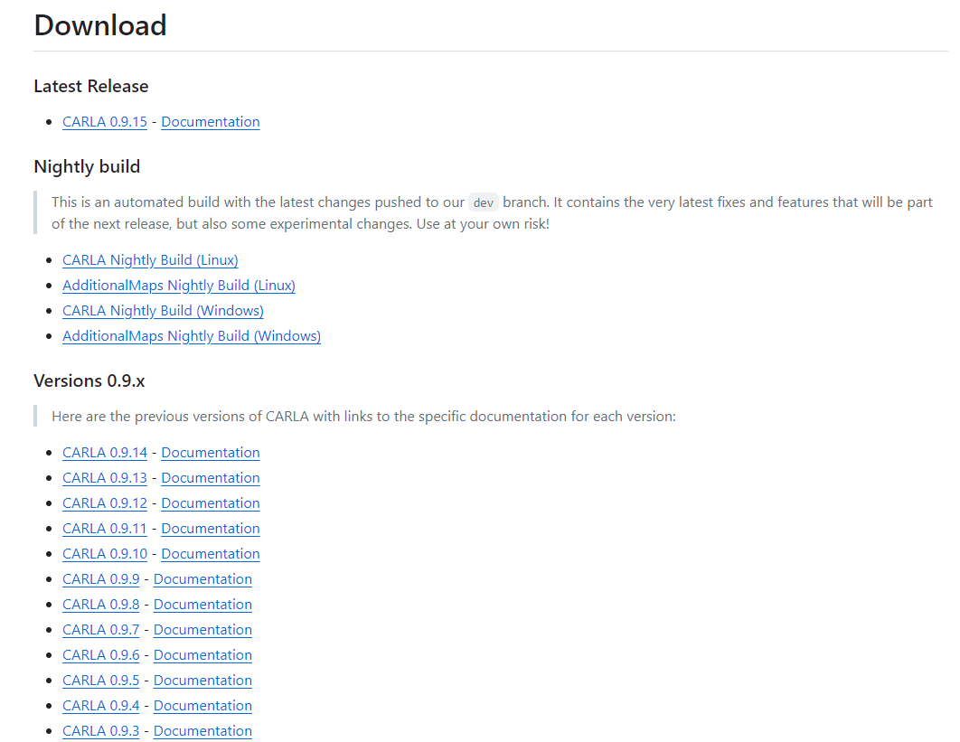
picture6The download page for the CARLA package on Github.
Step 2: Unzip the software package
The package contains a pre-compiled version of the emulator, Python API modules, and some scripts for example use. For Windows systems, simply unzip the package. For Linux systems, move the package to the import folder and run the following script to extract its contents:
1. cd path/to/carla/root
2../ImportAssets.sh
3) Install the client library
It is recommended to install the CARLA client library in a virtual environment to avoid conflicts when using multiple versions.
Step 4: Client Installation
The CARLA client library can be downloaded from PyPi (link provided).https://pypi.org/project/carla/This library is compatible with Python versions 2.7, 3.6, 3.7, and 3.8. To install it, you need pip/pip3 version 20.3 or later.Please run the following command:
1.# Python 3
2. install carla with pip3
3.# Python 2
4. pip install carla
Installation can also be performed from a .whl file located at PythonAPI/carla/dist/. There is one file for each supported Python version, indicated by the filename (e.g., carla-0.9.12-cp36-cp36m-manylinux_2_27_x86_64.whl indicates Python 3.6).Please run the following command and select the file that best suits your desired Python version.
1.# Python 3
pip3 install <wheel-file-name>.whl
2.# Python 2
pip install <wheel-file-name>.whl
The basic CARLA environment has now been installed.
4) Start CARLA
The method for starting the CARLA server depends on your installation method and operating system. A brief description of the startup methods is provided, and readers can choose according to their needs.
1.Debian installation:
1. cd /opt/carla-simulator/bin/
2. ./CarlaUE4.sh
2.Linux package installation:
1. cd path/to/carla/root
2. ./CarlaUE4.sh
3.Windows package installation:
1. cd path/to/carla/root
2. CarlaUE4.exe
After launching CARLA, a city view window will pop up. Users can use the mouse or the WASD keys on the keyboard to move the view forward, backward, left, and right.
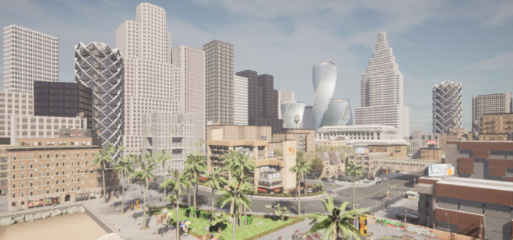
picture7CARLA Startup Screen
4) Other configuration settings
After starting and running CARLA, users can modify some configurations according to their own needs, such as...
1. ./config.py --no-rendering # Disable rendering
2. ./config.py --map Town05 # Change map
3. ./config.py --weatherClearNoon# Change weather
4. ./config.py --help # Check all the available configuration options

CARLA 0.9.15 Installation Example Based on Ubuntu 20.04
This article will illustrate the installation steps with an installation example for readers' reference and discussion.

Conda installation (Python environment)
This article uses Miniconda for Python environment configuration, which can be understood as a pre-downloaded scientific processing library. Miniconda is relatively lightweight, allowing users to flexibly select and install the necessary packages as needed, making it more flexible and customizable; users can download packages according to their requirements.
1) Downloading and installing Miniconda
Users can directly search for "miniconda" on Google or other search engines and download the corresponding resource files for the free version.
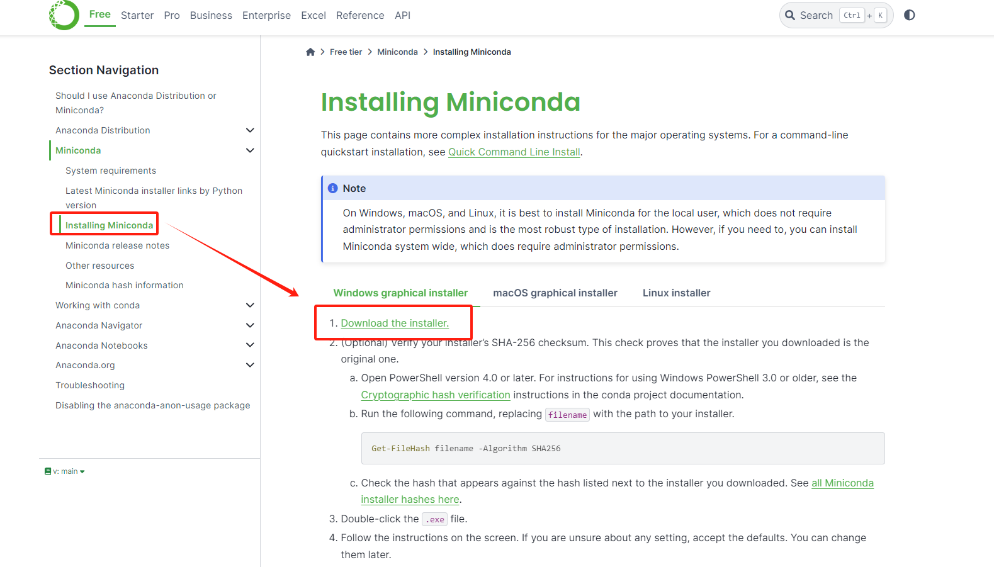
picture2Miniconda interface
Scroll down (the previous ones are older versions), select your desired conda version, or click install directly.
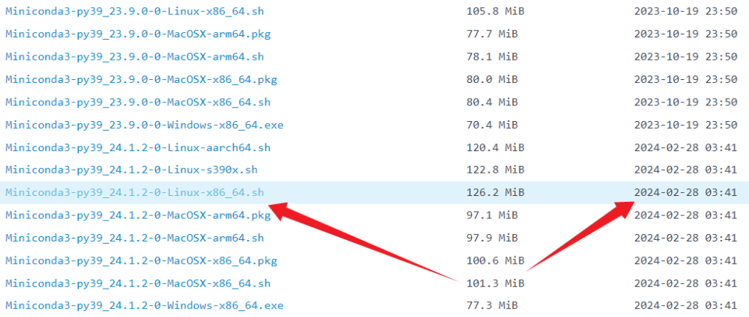
picture3Minconda resource interfaces for different versions
Alternatively, readers can install via command line depending on their needs. (Enter "yes" for all prompts during the installation process.)
wget https://mirrors.tuna.tsinghua.edu.cn/anaconda/miniconda/Miniconda3-py39_24.1.2-0-Linux-x86_64.sh
# Perform the installation command
bash Miniconda3-py39_24.1.2-0-Linux-x86_64.sh
2) Complete the installation
After installationCan be used in command prompt,enter“conda –version"Verify that the system is installed successfully. The command prompt displays..."conda version informationThis means the installation was successful.
3) Environmental preparation
sudo apt-get install libomp5 conda create -n carla python=3.10 # carla is the environment name; the Python version must be 10 or lower, but not too low.
pip install carla pygame setuptools wheel

Installation of CMake, Make, and Git
1) CMake installation
Download CMake version 3.15 or later, extract the files, and then add it to your environment variables.
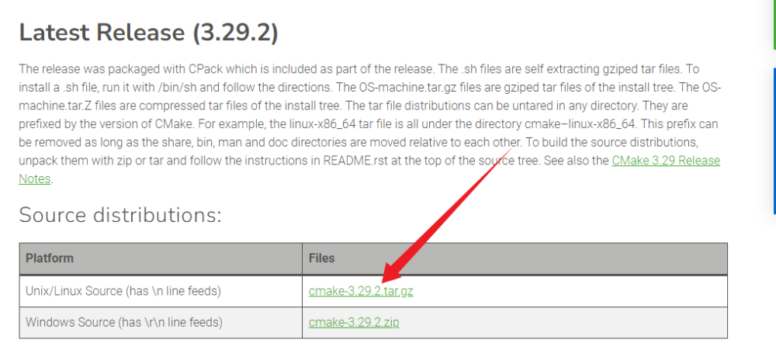
picture4CMake resource download page
# Unzip the file
tar -zxvf cmake-3.29.tar.gz
# Edit environment variables
vim ~/.bashrc
# Add to the last line
export PATH=$PATH:/home/cmake/bin
# Check if the installation was successful
cmake --version
2) Install using make
Download make version 3.81 or later, extract the files, and then add it to your environment variables.
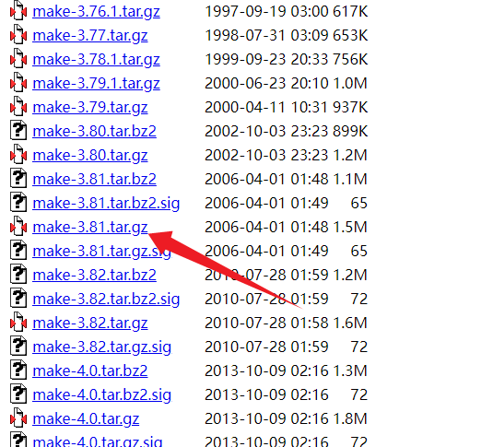
picture5make resource download page
# Unzip the file
tar -zxvf make-3.81.tar.gz
# Edit environment variables
vim ~/.bashrc
# Add to the last line
export PATH=$PATH:/home/make/bin
# Check if the installation was successful
cmake --version
3) Git installation
apt-get install git# If you cannot install git, use
sudo apt update
# Git configuration
git config --global username "Your Name" git config --global user.email " youremail@yourdomain.com "
# Add public key file
ssh-keygen -t rsa -C " youremail@yourdomain.com "
# View the public key file and add it to GitHub.
cat ~/.ssh/id_rsa.pub

UE installation
The most crucial step before installing Carla is installing the UE4 engine. Starting with Carla version 0.9.12, it uses Unreal Engine 4.26. Before installing Carla, ensure your GitHub account is connected to your Unreal Engine account.
1)Cloning and compiling UE files
# To clone UE4, you must ensure that UE is already linked to GitHub.
git clone --depth 1 -b carla https://github.com/CarlaUnreal/UnrealEngine.git
Navigate to the downloaded Unreal Engine folder and execute the following command. This process is very lengthy, please be patient.
./Setup.sh && ./GenerateProjectFiles.sh && make
# To check if the installation was successful, navigate to the UE folder /UnrealEngine/Engine/Binaries/Linux and execute ./UE4Editor. # If UE opens successfully, the installation was successful.
# Add environment variables after installation
sudo gedit ~/.bashrc export UE4_ROOT=~/UnrealEngine # Replace this with your own UE file path
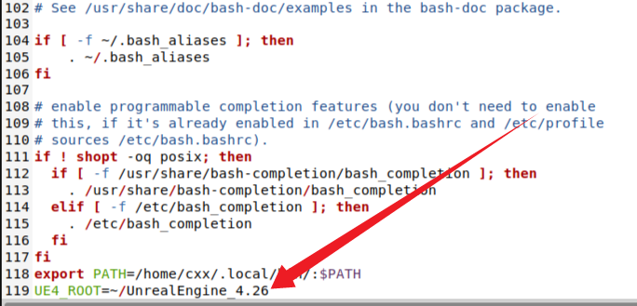
The environment variables after installation are shown by the arrow in the image. Users can change the path according to their own needs.

CARLA installation
- Cloning CARLA source code
git clone -b 0.9.13 https://github.com/carla-simulator/carla.git
2) Compile CARLA
Before compiling, you need to modify line 432 of the Setup.sh file. Since the URL provided when downloading Xerces is invalid and has been removed, the solution is to modify the Xerces download address in the Setup.sh file. Change the XERCES_REPO address in line 432 to https://archive.apache.org/dist/xerces/c/3/sources/; the version number does not need to be changed.
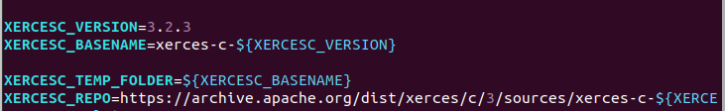
cd /carla # Navigate to your own Carla directory
./Update.shmake PythonAPImake launch

Common problems and solutions

Common problems during CARLA environment configuration
①•Permission issue: Use the following command to add permissions (replace this with your own name) to enable the use of bash xxx.sh by adding sudo before the command.
chmod +x Miniconda3-py38_4.9.2-Linux-x86_64.sh
② The environment file command can be ignored for now; the following code will be used for adjustment later.
conda env export > environment.yml
conda env create -f environment.yml
Git installation
# Git Installation
sudo apt-get install git
# Configure Git environment
git config --global user.name "username"
git config --global user.email "email address"
# Generate an SSH key and save it to /root/.ssh/id_rsa
ssh-keygen -C "email" -t rsa
# View the public key and add it to Githun
cat id_rsa.pub
# Test if the configuration is successful. If you see "you're successful", it means the configuration is successful.
ssh -T git@github.com

Common problems during CARLA installation
①./Update.sh
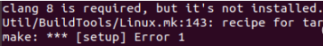
Modify the clang version in the installation script. The installation script is located in the home/carla/Util/BuildTools directory. The files to be modified are:
Setup.sh
– BuildOSM20DR.sh
– BuildPythonAPI.sh
Search for the keyword "clang" in these three folders and change the 8 to 10. If there is only "clang" without any numbers, you can ignore this step.
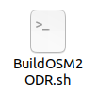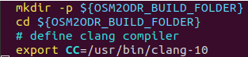
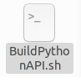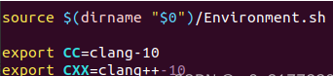
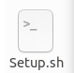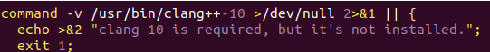
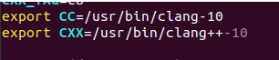
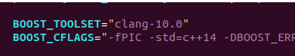
② The `make PythonAPI` command returned an error.
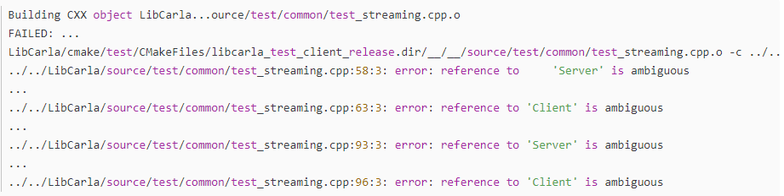
After observing the error message, it was found that the main cause of the error was the existence of multiple levels of Server and Client definitions in the test_streaming.cpp file. The solution was to open the target file carla/LibCarla/source/test/common/test_streaming.cpp and change Server and Client to carla::streaming::low_level::Server and carla::streaming::low_level::Client in lines 58, 63, 93, and 96 respectively, and then recompile. After a period of waiting, the problem was successfully resolved!

References
- CARLA Installation for Autonomous Driving Simulation Platformhttps://mp.weixin.qq.com/s/tCMGNXDZAPBpoCSlZpCYcg)
- Introduction and Installation of CARLA, an Autonomous Driving Simulation Platformhttps://zhuanlan.zhihu.com/p/105492011)
- Carla Autonomous Driving Simulation Platform Installation and Configuration Guide (https://zhuanlan.zhihu.com/p/621357659)
- Carla Environment Installation and Operation (Windows)https://mp.weixin.qq.com/s/xqUPDAUMWIpkf1oc1KhGHg)
- CARLA official website (http://carla.org/)

